Topic 6: Private Equity

Chapter 23: Introduction to Venture Capital

1. List FOUR distinct strategies encompassed by the term Private Equity.

- Venture capital. Generally, 5-7% over market.
- Leveraged Buyouts (LBOs)
- Mezzanine financing
- Distressed Debt Investing

2. Define venture capital.

- Involves equity investments in start-up ventures that are unable to attract capital from more traditional sources.
- Venture capitalists are in the business of financing these types of entities (immature, cash-flow negative firms).
- Illiquid
- Private investments in established, troubled companies.
- Where public companies repurchase all of their outstanding shares and turn themselves into private companies

3. Identify important developments in the history of venture capital.

The first firm was formed in 1946. American Research and Development. Set up as closed end funds.
- SBICs were established in 1958
- 1958. Draper, Gaither, and Anderson.
- 1985-1990 Pension Funds were very involved.
- Change to the prudent person law.
- The gatekeeper – investment advisers who came to prominence to advice pension funds and wealthy investors on the benefits of venture capital.

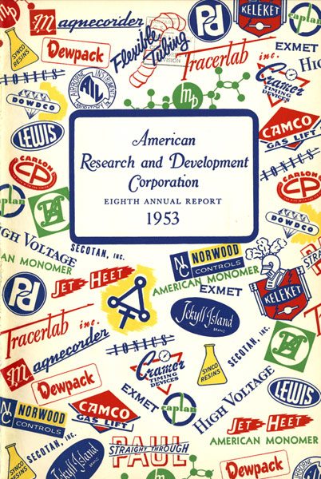 Note: “Research and Development Corporation”

4. Describe expected returns in the venture capital market relative to those in the public stock market.

- Each fund is managed by a general partner. The general partner is typically a corporation.
- Balance VC funds have a balance of late and early-stage companies.
- Return persistence

5. Identify the venture capitalist’s relationship with investors including the role of protective covenants and venture capital fees.

- Covenants relating to the overall management of the fund
- Covenants that related to the activities of the general partner
- Covenants that determine what constitutes a permissible investment

6. List and describe the aspects of the entrepreneur’s business opportunity upon which venture capitalists focus.

- Market
- Product
- Intellectual Property Rights
- Start-up Management Team
- Prior Operating History
- Financial Forecasts
- Financing Requirements
- Schedule
- Exit Plan

7. List sources of venture capital and describe how the structure of the venture capital marketplace has changed over previous years.

There have been three new sources of capital over the last 15 years.
- Endowments & Foundations
- Intermediaries
- Family offices.

8. List and describe various venture capital investment vehicles.

The four primary venture capital structures:

- Limited Partnerships
A limited partnership is not taxed. Instead, the limited partners pay taxes individually. The venture capitalist is the general partner and contributes capital along with the limited partners.
- his is the predominant form. Operates either 3c1 or 3c7 to avoid registration as an investment company under the investment Company Act of 1940
- Expected life of 10 years.
- Has a general partner.

- Limited Liability Companies (LLC)
An LLC is similar to a Limited Partnership, but has more definite rights and privileges, including the ability to sell new shares in the LLC to new investors.
- LLC
- Expected life of 10 years.

- Corporate Venture Capital Funds
Formed with a corporation’s excess cash. Outside investors are not allowed.
- To gain technology insights

- Venture Capital Fund-of-Funds
Investment in other funds, giving the investors broad exposure to many different industries.
    - It invests in other venture capital funds
    - Relatively new phenomenon
    - Diverse – broad range
    - Expertise of the fund-of-funds manager

9. List specializations within the venture capital industry.

- Stages of Financing (seed, early stage, mid-stage, late-stage, or mezzanine stage)
- Industry
- Geography
- Special Situation Venture Capital

10. Explain the life cycle of a venture capital fund and describe each of the stages of
financing.

Typically, investor capital is locked up for 10 years.
- Raise capital from outside investors
- Sourcing investments, reading business plans, due diligence
- Investment of capital
- Working with the companies
- Windup and liquidation. Profits are distributed to the VC people.

All leads to the J curve.

Chapter 24: Introduction to leveraged buyouts (LBOs)

1. Define leveraged buyouts (LBOs)

- A leveraged buyout (LBO) is a way for an investor or group of investors to take a public company private by purchasing all of the outstanding stock.
- LBOs are typically financed by using the firm’s assets and cash flows to secure debt financing (bonds and/or bank loans).
- When the investor or group of investors is the firm’s current management team, the transaction is referred to as a management buyout (MBO). Duracell is an example of this.
- After an LBO, control shifts to the LBO firm and management.
- Public shares are eliminated.
- Unlike leveraged loans, mezzanine debt is not paid off in installments (amortized). The principal is repaid as a bullet payment.
- Privatization fee is the charge for taking a firm “private,”

2. Identify important developments in the history of LBOs and describe the recent historical performance of LBOs.

- 1976 -KKR
- 1980 – Junk Bonds
- 1989 – Height of the LBO boom
- 1990s - slow down because of recession in 91 and LTCM
- 2001 – ECNs made shares in private equity available



3. Define earnings before interest, taxes, depreciation, and amortization (EBITDA).

- Earnings before Interest, Taxes, and Depreciation + Depreciation and Amortization

4. Compute the annual compounded return for a theoretical LBO investment.

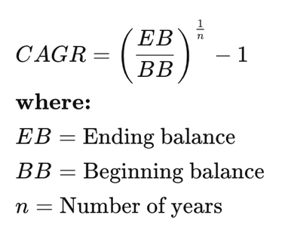

5. Describe the layers of LBO financing.

- Senior debt
- Mezzanine debt
- Equity

6. Compare the five general categories of value creation methods through LBOs.

- LBOs that improve operating efficiency
- Unlocking an entrepreneurial mindset
- The overstuffed corporation
- Buy and build strategies
- LBO turnaround strategies

7. Describe the role of the Material Adverse Change clause in LBO failures.

- Becoming much more common.
- MAC clauses allow for a PE firm to scuttle the deal if there is some unforeseen and negative change to the business of the target company.

8. Compare the structure of LBO funds to that of hedge funds and venture capital
funds.

- Almost all of them are designed as Limited Partnerships.

9. Describe fee structures for LBO firms.

- Management fees 1.25% - 3%
- Profit sharing fees
- Privatization fees - kinda arbitrary
- Breakup fees
- Divestiture fees

10. Explain the concept of a vintage year as it relates to the J-curve effect.

- Have a return that exhibits a J curve effect
- Vintage year is a way to compare private equity funds based on their year of formation.
- Way to make and apple-to-apple comparison.

11. Compare LBOs to venture capital deals.

- LBO target company has a track record with proven products and/or services
- Management of the LBO target also has an established track record
- An IPO exist strategy is much more realistic for an LBO versus a venture capital deal since the
- LBO target had public stock outstanding previously

12. Outline risks associated with LBOs.

- The real risk of a leveraged buyout is the financial pressure the debt places on the company. If some unforeseen event occurs, it is possible for all the investors to lose their entire stake in the deal.
- Buyouts are also dependent on precise calculations of the future cash flows required to satisfy creditors.
- Finally, economic downturns, or an increase in costs, can result in the company's inability to meet all their financial obligations. Deals can turn sour very quickly when this happens.

13. Define corporate governance and list three types of agency costs associated with
LBOs.

Agency costs come in three forms

- Cost to align management’s goals with shareholders’ goals
- Cost of monitoring management
- Deterioration of shareholder value

14. Describe 3important benefits for the public market that result from principles of corporate governance applied by LBO firms.

- Strong corporate governance principles (incentives for managers and monitoring systems) enacted during the LBO should remain in place after the company becomes public again, maintaining the alignment of interest between management and the new public equity holders.
- Managers of firms with lax corporate governance and shareholder monitoring must live with the threat of being removed from their position as a result of an LBO. Such a threat provides incentive to enact better corporate governance principles
- Management incentive and shareholder monitoring programs created by LBO firms can provide a road map for management and shareholders after the firm becomes public again.

15. Describe the practice of merchant banking.

- A merchant bank is historically a bank dealing in commercial loans and investment.
- The providers of senior debt are commercial banks, finance companies, and insurance companies.
- The providers of mezzanine debt are debt funds, institutional investors, insurance companies, and investment banks.

Chapter 25: Debt as Private Equity Part 1

1. Describe the general purpose of mezzanine financing and the rationale for its return expectations.


- Financing to bridge a gap in time
- Financing to bridge a gap in capital structure
- Financing to bridge a gap in an LBO

2. Compare mezzanine funds to other forms of financing

- Return expectations
- Interest rate
- Investment team

3. Recognize the type of transactions that use mezzanine financing

- Does not necessarily translate into management control
- Companies must have a cash flow

4. Identify advantages of mezzanine debt to the investor and to the issuer
- High equity like returns
- Priority of payment
- Schedule of repayment
- Board representation
- Restrictions on the borrower

5. Describe restrictions on the senior creditor and the mezzanine investor that may be included in the inter-creditor agreement

- Subordination
- Acceleration
- Drawdown
- Amendment restrictions
- Assignment
- Insurance proceeds
- Takeout provisions

Chapter 26: Debt as Private Equity Part II

1. Identify factors that have influenced growth in the distressed debt market since the 1990s

- There has been an expansion in the number of types of commercial loans being resold
- Banks and other lenders are using risk management techniques to maintain a specific risk return balance.
- The level of debt has been rapidly increasing
- There was a strong economy in the 1990s which led to many start ups

2. Describe the nature of distressed debt investors

- Sometimes they are called vultures
- It is a profitable endeavor with typical returns of 20% or higher.

3. Understand the basics of the Chapter 11 bankruptcy process

- Mezzanine capital is considered a type of equity financing. Senior lenders often require mezzanine capital to be fully drawn down before extending senior debt. Mezzanine investors may "take out" or purchase the senior debt once it is repaid to a certain level.
- Chapter 11 was introduced by the Bankruptcy Code of 1978 and provided the many changes that impact the distressed debt marketplace. One of the key purposes of the Code was to favor reorganization over liquidation. This shifted the focus from asset valuation to going concern valuation.

4. Illustrate how an investor can gain control of a company through CHAPTER 11
bankruptcy proceedings

 Note: “Chapter 11. Reorg the band”

- Classification of claims:
- All issues of subordinated debt by a company would constitute one class of creditor under a bankruptcy plan.
- Plan of Reorganization
- Evolution of debt to own
- Prepackaged bankruptcy filing
- Voting within a class
- Blocking Position
- Cram down: Loan changes and bankruptcy is crammed down creditor’s throats.
- Absolute Priority
- Debtor-in-possession financing (DIP)
- CHAPTER 7 Bankruptcy: under Chapter 7 bankruptcy, the company is no longer considered a going concern. Chapter 7 results in a liquidation of the company’s assets for the benefit of its debt holders. Essentially it shuts down its operations and parcels out its assets to its creditors.
- The biggest difference between Chapter 11 and Chapter 7 is that Chapter 11 is a reorganization bankruptcy, while Chapter 7 is a liquidation bankruptcy. So, if you file for Chapter 7, you'll have to sell your assets to pay as many creditors as possible. Chapter 11 is rarely used for individuals.
- A debtor in possession in United States bankruptcy law is a person or corporation who has filed a bankruptcy petition but remains in possession of property upon which a creditor has a lien or similar security interest. A corporation which continues to operate its business under Chapter 11 bankruptcy proceedings is a debtor in possession.

5. Recognize the types of active and passive distressed debt strategies.

- Gain control of the company
- Play an active role in the bankruptcy and reorganization process
- Passive – buy debt that no one else wants

6. Describe an arbitrage strategy in the distressed debt market
In essence, it is going long one security in a company's capital structure while at the same time going short another security in that same company's capital structure. For instance, "long sub bonds, short senior bonds", or "long equity, short CDS", or maybe "long 1st lien bank debt, short 1st lien bonds."

7. Identify two of the main risks of distressed debt investing.

- Business risk
- Simply, the company could get worse and go lower.
- If reorganization does not occur, it could go into a downward spiral.
- It may seem strange, but creditworthiness is not a concern. Credit is already bad.
- Global Crossing example.
- Lack of liquidity
- Fragmented marketplace.
- Getting out of positions (Loews) can be very difficult

Chapter 27: Trends in Private Equity

1. Describe the efficiency and development of an auction market environment for
private equity.

- Auction Market
- This is a sign of an efficient market

2. Describe the advantages and disadvantages of the Club Deal in the LBO market.

- First Advantage: allows for investment when more capital is required
- Second Advantage: allows for greater investment over your own limit. Say 25%.
- Club Deal: when many firms work together on the details of a certain firm.
- 16% of deals between 2000 and 2007 were club deals

3. Describe the advantages and disadvantages of the development of a secondary market for private equity.

Advantages
- Provides liquidity
- More effective diversification
- Allow investors to realize profits sooner
- Gain access to future fund

Disadvantages
- Lack of opportunity
- Incentive fees
- Reduced returns

4. Contrast deal terms for hedge funds with deal terms for private equity firms.

- Hedge Funds have better deal terms. Hedge Funds have a much lower hurdle rate.
- Can receive incentive fees at any time
Based on NAV vs. realized profits form the portfolio
- Hedge fund fees are collected on a regular basis
- Hedge fund does not need to recoup management fees before paying incentive fees
- Hedge funds typically do not have provisions for the clawback of management or incentive fees
- Hedge funds typically target a return in excess of cash

5. Define leveraged loans.

- Loans made to borrowers who do not carry an investment grade credit rating
- Leveraged Bank Loans: Is made up of loans to companies with a credit rating below investment grade, or loans that are priced at 150 basis points or greater spread over LIBOR.
- Have the most consistent returns with a slight negative skewness.

6. Describe the interest of the various parties in the leveraged loan market including equity firms and collateralized loan obligation funds.

- Institutional Funds
- US Banks
- European Banks
- Finance Companies
- Insurance Companies
- Asian Banks
- Canadian Banks
- Securities Firms

Growth of the leveraged loan market:
- Convergence of the bank loan and high yield bond markets
- Insurance companies playing an increasing role in the bank loan market
- Acceptance of bank loans by institutional investors
- Securitization through CLOs
- Greater efficiency in banks managing their risk capital

7. Private investments in public entities (PIPEs) describe how a traditional PIPE transaction works.

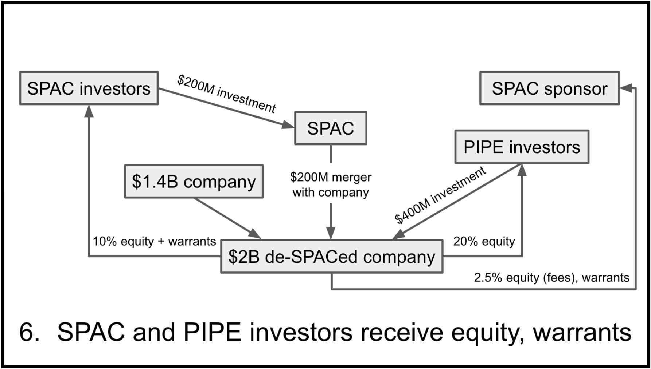

- A private equity transaction where an investor or group of investors bargain directly with a public company to acquire an equity position.
- Significant positions in a company at a discount.
- A traditional PIPE is one in which stock, either common or preferred, is issued at a set price to raise capital for the issuer.
- A structured PIPE, on the other hand, issues convertible debt (common or preferred shares)
- The attractiveness of PIPE transactions has waxed and waned since the late 1990s. For private equity investors, PIPEs tend to become increasingly attractive in markets where control investments are harder to execute.
- Generally, companies are forced to pursue PIPEs when capital markets are unwilling to provide financing and traditional equity market alternatives do not exist for that particular issuer.
- Through the acceleration of the credit crisis in September 2008, PIPE transactions provided quick access to capital at a reasonable transaction cost for companies that might otherwise have been unable to access the public equity markets.
- Recently, many hedge funds have turned away from investing into restricted illiquid investments.

b. Explain how toxic PIPEs work.



- Newly Public companies usually have a relatively small float, or outstanding stock that is actually public, generally in the 5 to 30 range. These companies are less inclined to issue public stock and risk further dilution on their existing shareholders. It is better to do a private placement of public equity, so the equity stays out of the public market until the company can fully put in place its business strategy
- Wall Street can be hard on new firms that do not meet profitability or sales targets. PIPE financing will not “react as badly” to missed expectations.
- Due to the company’s unstable balance sheet and uncertain cash flows, the public stock market is closed to further public offerings of its common stock.
- Private equity investors agree to provide more capital in return for PIPEs that can be converted into stock at a floating conversion rate and at a discount to the common stock price.
- Either the private equity investors short the stock of the company or the company’s fortune decline (or both). The is the catalyst running the structured PIPE into a toxic PIPE.
- The downward pressure triggers larger and larger conversion ratios for the PIPE investors, resulting in greater and greater dilution of the common stock of the company.

c. Describe a safeguard that can help prevent toxic PIPEs and death spirals.

- A toxic PIPE: is a structured PIPE in which the floating or reset convention rate allows the PIPE investor to receive greater and greater amounts of common equity as the price of the issuer stock falls. This can create a death spiral.

- To prevent these death spirals, you can have price floors, preventing an unending increase in the conversion ratio.


www.placementtracker.com
- Here’s a product that generates alarm and pained cries that institutional investors are running around harming small-cap and mid-cap companies: PIPEs. PIPE stands for private investment in public equity. In a PIPE deal, a public company typically issues unregistered equity-linked securities to a kaffeeklatsch of power investors at a discount to the price of the issuer’s common stock at the time the deal is closed. The issuer commits to registering the securities with the Securities and Exchange Commission so they can be resold to the public, typically within 90-120 days.

- Everyone is happy, no? Public companies get a much-needed cash infusion quicker, with less fanfare, and at better terms than they could otherwise score from Wall Street, while investors get a chunk of the company’s securities at a discount to the market price.

- PIPEs hit the headlines starting in 2000, when high-growth, small-cap companies in desperate need of financing — typically tech and telecom companies — turned to the PIPEs market. But instead of getting the financing that would save them, the companies tanked. Within a year of their deals closing, dozens of companies with so-called “death-spiral” or “toxic” structured PIPEs had lost 96 percent, 97 percent, 98 percent of their value. The list is a Who’s Who of failed enterprises: MicroStrategy Inc., Quokka Sports, Log On America, Ariad Pharmaceuticals, IFS International Holdings and eToys, just to name a few. Total PIPEs issuance that year was $24.7 billion.

- In a typical death-spiral structure, a company issues convertible preferred stock or convertible debentures that convert into common stock; however, instead of being fixed, the conversion price changes based on how the issuer’s common stock performs after the deal is closed or over some predetermined period in the future (or some other trigger). If the price of the common stock falls within that period of time, the conversion price drops according to a set formula, enabling the investor to get more stock for the same amount of principal. The problem with that structure, as issuer after issuer — as well as public investors — discovered, was that PIPE investors had every incentive to pound the price of the common stock down after the deal closed so they could rake in more stock.

- Myriad lawsuits and civil litigations have come and gone, and the PIPEs market has changed. Structured PIPEs — deals that offer investors price protection through conversion prices that are reset or variable — represent a far smaller portion of the overall PIPEs market nowadays. In 2000, structured PIPEs represented 13 percent of the total PIPEs issuance, according to PlacementTracker, an industry research firm; through November 1 of last year, structured PIPEs were 7 percent of the market.

- The current structured deals are also designed differently. They typically include hard or soft floors that prevent “high-level dilution,” thereby reducing the incentives of investors to push the stock down, says Steven Dresner, publisher of “The PIPEs Report” and co-author of “PIPEs: A Guide to Private Investments in Public Equity.” Many PIPE contracts also specify that the investors cannot short-sell or can only short a certain amount of the company’s stock over a period of time.

Chapter 28: The Economics of Private Equity

1. Compare the investment results of investing in the four private equity categories
to that of investing in the S&P 500.

- Venture Capital
- VC investments had the highest return of the four types of investments
- Higher unsystematic risk, with less diversification and higher specialization.
- Business risk is high – because typically they tend to be pre-IPO companies.

- Leveraged Buyouts
- LBOs typically invest in firms beyond the IPO stage and LBO firms are typically more diversified.
- Close second behind – VCs. LBO firms are typically more diversified.
- Payout pattern for LBOs is shown to exhibit a new symmetrical distribution

- Mezzanine Debt
- Was in line with that of the S&P 500.
- In theory it should underperform the S&P 500 because of the downside protection of the debt component.
- Its like a hybrid of debt and equity.
- Mezzanine debt typically has an equity kicker
- Sharpe ratio of .87.
- Similar to senior debt, mezzanine debt generally has a repayment schedule, which may not being for several years.

- Distressed Debt
- Distressed debt is expected to perform somewhere between mezzanine debt and LBO investments with regards to return.
- Mezzanine → distressed debt → LBO
- Strategy for investing in distressed debt,
- Recycling private equity
- Distressed buyouts
- Distressed debt arbitrage.

2. Compare the return distributions of the four private equity categories, given by
the average, standard deviation, skewness, and kurtosis.

- Venture Capital
Positive skewness and kurtosis
- LBOs
LBOs are shown to exhibit a near symmetrical distribution
- Mezzanine Debt
More symmetrical
- Distressed Debt
Distressed debt has the lowest return

3. Rank the risk-adjusted average returns (Sharpe ratio) for the four private equity
categories and understand reasons for the differences in performance.

- Venture Capital
Return: 4.13%
.27
- LBOs
Return:
.4
- Mezzanine Debt
Return: 3.00%
.4
- Distressed Debt
Return: 1.11%
.12

4. Discuss the diversification benefits of including private equity in a portfolio of traditional investments.

- Efficient frontier is shifted up and to the left
- Only Mezzanine debt has a positive correlation with Government treasuries

